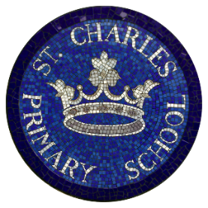
St Charles Catholic Primary School
Autumn Lunch Menu

Week 2
 | Monday | Tuesday | Wednesday | Thursday | Friday
Hot Main Dish | 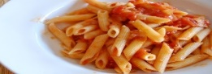  Penne Pasta Cheese and Tomato Bake | 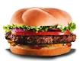  Beef Burger  Wedges | 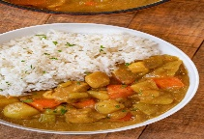  Chicken curry with rice | 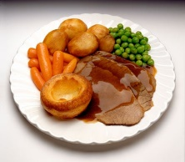  Roast of the Day | 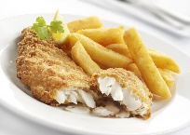  Cod fillets & chips
Hot Vegetarian Dish | 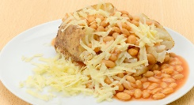  Baked Potatoes  with beans or tuna or cheese | 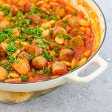  Vegetarian Sausage Casserole | 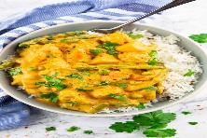  Vegetable Korma | 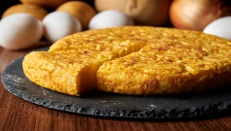  Spanish omelette | 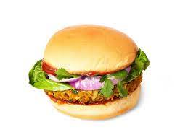  Vegetarian Burger
Salads | Bean Salad | Mixed Green salad  & Coleslaw | Sliced peppers, cucumbers &carrot sticks | Mixed Green Salad | Sliced peppers, cucumbers & carrot sticks
Vegetables | Peas | Green beans | Sweetcorn | Mixed vegetables | Baked Beans
Desserts | Carrot Cake  Vanilla Custard  Fresh Fruit: sliced apple and oranges | Rice Pudding and Jam  Fresh Fruit: sliced apple and oranges | Fruit Salad  Fresh Fruit: sliced apple and oranges | Fruit Crumble& Custard  Fresh Fruit: sliced apple and oranges | Strawberry Jelly & Ice cream  Fresh Fruit: sliced apple and oranges

Cool Water, Fresh Seasonal Fruit, Fresh Vegetables and Wholegrain Bread served daily
(All dishes are subject to delivery and may vary from time to time)

