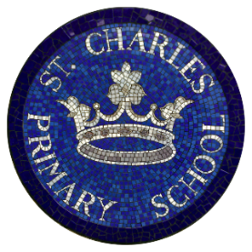
St Charles Catholic Primary School
Autumn Lunch Menu

Week 3
 | Monday | Tuesday | Wednesday | Thursday | Friday
Hot Main Dish | 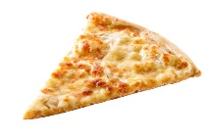  Margherita Pizza  & Wedges | 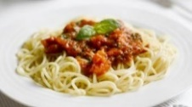  Spaghetti Bolognese | 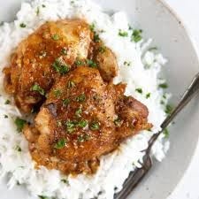  Chicken Thighs  & Rice | 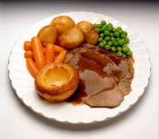  Roast of the day | 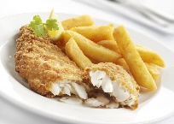  Cod fillet & chips
Hot Vegetarian Dish | 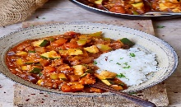  Ratatouille and rice | 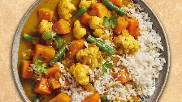  Vegetable Curry | 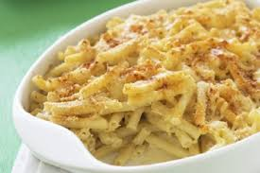  Macaroni cheese | 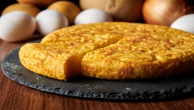  Spanish Omelette | 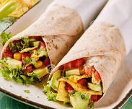  Vegetarian Tortilla Wraps
Salads | Bean Salad | Mixed Green salad | Sliced peppers, cucumbers &carrot sticks | Mixed Green Salad | Sliced peppers, cucumbers & carrot sticks
Vegetables | Peas & Sweetcorn | Mixed Vegetables | Green Beans &  Carrots | Broccoli & cauliflower florettes | Baked Beans & colslew
Desserts | Apple Sponge Vanilla Custard  Fresh Fruit: sliced apple and oranges | Yogurt with seasonal fruits  Fresh Fruit: sliced apple and oranges | Fruit Crumble with custard  Fresh Fruit: sliced apple and oranges | Chocolate Cake  Custard  Fresh Fruit: sliced apple and oranges | Strawberry Jelly & Ice cream  Fresh Fruit: sliced apple and oranges

Cool Water, Fresh Seasonal Fruit, Fresh Vegetables and Wholegrain Bread served daily
(All dishes are subject to delivery and may vary from time to time)

