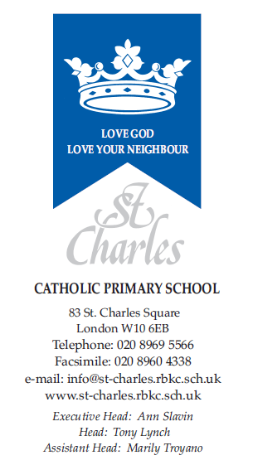

April 2024

Dear Parents/Carers,

Welcome back after the Easter holidays. We hope you had a lovely Easter holiday and enjoyed the break. Our topics for this term are ‘Do all superheroes wear capes?’ and ‘What will happen next?’
We will continue to focus this term on the Early Learning Goals from the Early Years and Foundation Stage Curriculum.

Personal, Social & Emotional Development
Children will continue to demonstrate acceptable school behaviour and learn to accept one another’s differences through conflict resolution. They will be learning to show sensitivity to the needs and opinions of others through discussions about feelings and ideas, and they will work as a class to understand and follow the classroom rules and routines. They will also be encouraged to develop their confidence and participate in small group and whole class sessions more consistently.

Communication and Language and Literacy
Please continue to encourage enjoyment of reading at home with regular reading of a variety of books, and ensure that key questioning is happening to encourage comprehension skills and phonological awareness. Please remember that reading books and records need to be returned every Monday. Children’s homework must be completed and returned every Friday.

Children will be learning and expected to do the following:
- Demonstrate understanding when talking with others about what they have read (comprehension).
- Write some words which are spelt correctly and others which are phonetically plausible (using appropriate sounds).
- Write meaningful and simple sentences which can be read by themselves and others.
- Read and understand simple sentences, and ‘sound out’ decodable words using phonic knowledge as well as know some words that are not decodable (words of the week) and read them aloud correctly.
- Listen to stories and accurately respond to what they hear with relevant comments and questions.
- Answer ‘how’ and ‘why’ questions about their experiences and in response to stories or events.
- Use past, present and future forms accurately when talking about events.
- Develop their own narratives and explanations by connecting ideas.

Mathematics
In Maths this term, children will be expected to do the following:
- Count reliably with numbers from 1 to 20, place them in order and say which number is one more/one less.
- Add and subtract two single-digit numbers and count on or back to find the answer.
- Solve problems, including doubling, halving and sharing.
- Use everyday language to talk about capacity, distance, and time.
- Comparing numbers and quantities.
- Number bonds up to 5 and then to 10.

Understanding of the World
In Understanding of the World, children will be learning and expected to:
- Understand some important processes and changes in the natural world around them, including the seasons and changing states of matter. We will be carrying out weekly experiments during our topic ‘What will happen next?’
- Know some similarities and differences between things in the past and now, drawing on their experiences and what has been read in class.
- Describe their immediate environment using knowledge from observation, discussion, stories, non-fiction texts and maps.

Information Technology
We will be visiting the computer suite, as well as continuing to explore other various technologies available such as the Beebots, the listening centre, programmable microphones and iPads. We will be talking about how technology is used at home, at school and at work. Please continue to support your child where possible in their development and control of a computer mouse and use of a keyboard.

RE
Our RE topic this term is ‘To the Ends of the Earth’.
- Story of Pentecost (simple telling).
- The early Christian community (Acts 2:42-47)
- Coming of the Holy Spirit at Pentecost.
- The Good News of Jesus lived out by the early Christian community.
- Pentecost is a special celebration in the Church.
- Sunday is a special day for the Church to celebrate.

Expressive Arts and Design
We will be involved in creative activities related to our topic of ‘Do all superheroes wear capes?’. In particular, children will be learning and expected to:
- Safely use and explore a variety of materials, tools and techniques, experimenting with colour, design, texture, form and function.
- Represent their own ideas, thoughts and feelings through design and technology, art, music, dance, role-play and stories.
- Make use of props and materials when role-playing characters in narratives and stories.
- Invent, adapt and recount narratives and stories with peers and their teacher.
- To evaluate their work.

Music
Reception children dive into “Noticing Patterns and Describing the Music.” This unit encourages children to become more attentive listeners. They learn to identify patterns within music and describe their musical experiences, nurturing their ability to engage with and respond to different sounds and melodies. Children will engage with rhymes, poems, nursery rhymes and songs, expressing their feelings and thoughts through music, enhancing language skills. They are becoming more attentive listeners, recognising and describing patterns within music, fostering an ability to engage with different musical experiences.

Physical Development
This term PE will take place on Wednesday. The children will be doing Athletics and practising for sports day. Children can come to school in their PE kit and stay in their kit for the day. PE kit is navy bottoms, white t-shirt and black, white or navy trainers.

Fine Motor Skills
- Hold a pencil effectively in preparation for fluent writing – using the tripod grip in almost all cases.
- Use a range of small tools, including scissors, paintbrushes and cutlery.
- Begin to show accuracy and care when drawing.

Finally, as this is the final term before Year 1, the children’s daily routine will gradually begin to reflect that which is expected in Year 1 as we move into the second half term. This will help to prepare the children through this transition period.

Thank you for your continued support, and we look forward to a great term ahead!

Yours sincerely,

Ms Almasri
Reception Teacher

