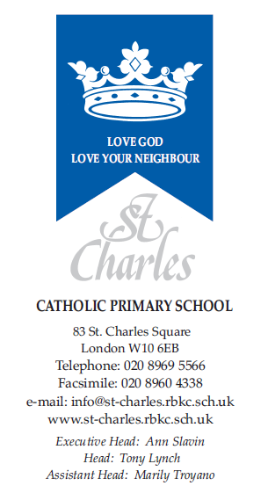

April 2024

Dear Parents/Guardians,

Welcome back! I hope you have had a lovely Easter break and that everyone is rested and ready for the summer term. This term in nursery, our starter topics will be ‘Growing’ where we will be planting cress seeds, peas and sunflowers, ‘Who Will Help Bear?’ where we will be learning about people who help us such as the police, fire service, vets and medical professions and ‘What happens Next?’ which covers transitions to Reception and thinking about simple science concepts and experiments.

Personal, Social & Emotional Development

Children will continue to follow our classroom and school rules as well as continue to play and work together in a friendly and kind manner. This half term we will have a particular focus on being considerate to others needs, to share and take turns and begin to resolve minor conflicts with little adult support.

Communication and Language and Literacy

This term in Nursery, we are going to be having extra focus on working in small communication groups with a grown up each week. The purpose of these activities will be to ensure that the children are able to do the following in preparation for starting reception class in September:

- Listen to others 1:1 and in small groups.
- Listen to stories with increasing attention and recall.
- Join in with repeated refrains and anticipates key events and phrases in rhymes and stories.
- Opportunities to ask and answer appropriate questions.
- Build up and extend their use of vocabulary.

In phonics, our focus will remain on identifying the initial sounds of words, and on blending and segmenting simple CVC words. We also will be learning to recognise, read and write the letters s, a, t, p, i and n. Children will bring home works sheets that will support this learning.
We encourage you to continue to work with them by reading a variety of books and getting the children to talk about the stories.
Each day the children are invited to ‘sign in’ to class, either by copying their name from their name card or by writing it from memory.

Mathematics

In Maths, children will be expected to do the following:
•Recite numbers in order to 10.
•Know that numbers identify how many objects are in a set.
•Begin to represent numbers using fingers, marks on paper or pictures.
•Sometimes match numeral and quantity correctly.

Understanding of the World

In Understanding of the World, children will be learning and expected to:
•Talk about some of the things they have observed such as plants, animals, natural and found objects.
•Talk about why things happen and how things work.
•Show care and concern for living things and the environment

Religion
In RE this term we are learning about Pentecost and the Holy Trinity. We will be furthering our understanding of what it means to be part of God’s family. We will also continue to learn and practice the ‘Our Father’ and ‘Hail Mary’ prayers, as well as our school daily prayers.

Expressive Arts and Design

We will be involved in creative activities related to our topics. In particular, children will be learning and expected to:

•Use available resources to create props to support role-play.
•Capture experiences and responses with a range of media, such as music, dance and paint and other materials or words.
•Create simple representations of events, people and objects.
•Choose particular colours to use for a purpose.
• Introduce a storyline or narrative into their play.

Physical Development

This half term we will also have a particular focus on children being able to:

- Negotiate space successfully when playing racing and chasing games with other children, adjusting speed or changing direction to avoid obstacles.
- Experiment with different ways of moving.
- Hold a pen or pencil in a proper grip.
- Copying letters from their name.

Sports day will take place on Monday 8th July in the afternoon. We will confirm the start time closer to the date.
We also invite parents and carers in for our Nursery Graduation Show and to join us for a celebration picnic afterwards. This will be on Friday 21st June at 2pm.

Thank you for your continued support, and we look forward to a great term ahead!

Yours sincerely,

Mrs Meriel McCauley (Nursery Teacher)

