**RE Home Learning - 14th June 2024**

**Gospel: Heaven is like small seeds growing strong (**Mark 4:26-34)

***Using the Wednesday Word link below, read this Sunday’s Gospel   
and reflect on the questions below with your family.***  ***You will have an opportunity to discuss them again next week in School.***

<https://www.paperturn-view.com/uk/wednesday-word/messenger?pid=MTA101634&v=5.5>

Why did Jesus tell his disciples these two parables? What was he trying to teach them?

Who do you think the man in the first parable is supposed to be?

Who are the seeds?

Why is Heaven like this, do you think? What did Jesus say about the smallest and weakest going to Heaven?

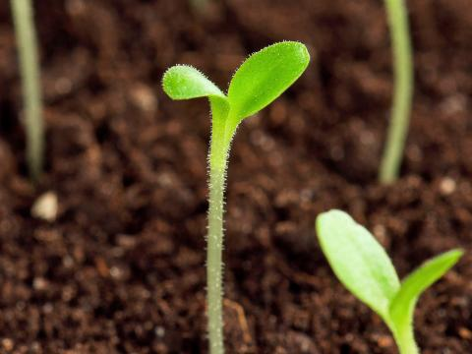

Jesus said, “I commission you to go out and to bear fruit. Fruit that will last”. What did he mean by saying, “fruit that will last”? How do we know that the fruit has lasted?