**RE Home Learning - 13rd September 2024**

**Gospel: Who do the people say that I am? (**Mark 8:27-35)

***Using the Wednesday Word link below, read this Sunday’s Gospel   
and reflect on the questions below with your family.***  ***You will have an opportunity to discuss them again next week in School.***

<https://www.paperturn-view.com/uk/wednesday-word/messenger?pid=MTA101634&v=5.5>

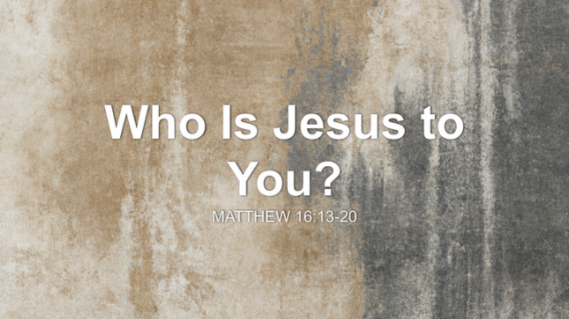Why do you think Jesus asked his disciples, “Who do the people say I am?”?

Jesus asked his disciples, “Who do you say I am?”? What would you have said?

Peter called Jesus ‘The Christ’ What does Christ mean and why do you think Jesus wanted this to be a secret?

What did Jesus predict was going to happen? Can you put it in your own words?