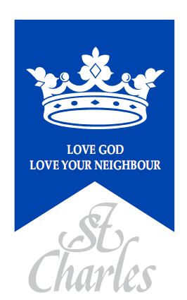
St. Charles Catholic Primary School
83 St Charles Square, London, W10 6EB

APPLICATION FORM FOR ADMISSION TO NURSERY

Start date: September 2025

Child’s Details
Child’s Forename:
Child’s Surname:
Date of Birth:
Gender:
Home Address:
Postcode:

Parent(s)/Carer(s) Details
Parent(s)/Carer(s) name:
Telephone number(s):
Email:
Relationship to child:  Circle as appropriate | Mother / Father  Other  (please specify)_____________ | Mother / Father  Other  (please specify)_________________

Details of Religion
Religion of child:
(Please indicate)

Parish you live in:
Church where child was baptised:

Date of baptism, (Original copy of baptism certificate to be returned with this form):
Church you currently attend:

Class details of brothers and / or sisters at this school who will still be attending at date of admission: | Name(s): | Class/es:
Is your child ‘looked after’ by the Local Authority, adopted or subject to a residency or special guardianship order, having previously been ‘looked after’? Please circle. |  | Yes / No
Does your child have exceptional medical, pastoral or social needs? Please circle. (Professional evidence will be required.) |  | Yes / No

The school is committed to protecting the information provided by parents / carers and using it only for the purpose for which is was obtained. For information on the school’s Privacy Notice please look on the school website or contact the school for a hard copy.

I confirm that I have read and understood the Admissions Policy and that the information I have provided is correct. I understand that I must notify the school immediately if there is any change to these details and that should any information I have given prove to be inaccurate that the governors may withdraw any offer of a place even if the child has already started school.

Signed……………………………………………………. Date…..…………………….

Notes:

Nursery Offer

Children aged 3 -4 years can access 15 or 30 hours of free nursery provision (depending on eligibility). We offer a variety of session times:
- 15 hour morning sessions 8.50am to 11.50am
- 15 hour afternoon sessions 12.20pm to 3.20pm
- 30 hr places offering full days (8.50am – 3.20pm)

Funding 30 hour places – working parents may be entitled to a further 15 hours of childcare each week (30 hours/extended entitlement). To check if you are eligible, please see the link below:

www.gov.uk/government/publications/30-hours-free-childcare-eligibility

The extended funding does not cover childcare over the lunch break. This will be charged at £3.00 a day. Please provide a packed lunch as lunch is not provided.

Parents who are not eligible for Extended Funding have the option to pay for the extra 15 hours at £7.00 per hour and £3.00 for lunchtime, which equals to £24.00 a day.

Checklist: Have you enclosed?
- ORIGINAL COPY of Birth Certificate
- ORIGINAL COPY of Certificate of Baptism (if applicable)
- 2 X COPIES of proof of address (used for this application) eg. current Council Tax,
gas, electricity or water bill or bank statement (less than 3 months old)
- Completed Free School Meal form

Please indicate how you heard about St. Charles Catholic Primary School:

- A friend
- Open day
- Parish Newsletter
- Local Authority

- Other: _ _ _ _ _ _ _ _ _ _ _ _ _ _ _ _ _ _ _

---------------------------------------------------------------------------------------------------------------------------------------

For office use: Documents submitted by parents
- Copy of Birth Certificate

- Copy of Certificate of Baptism
- FSM form
- Copy proof of address X2
- Other documents attached: -

Received by___________________ Date: _______________

