**RE Home Learning - 15th November 2024**

**Gospel: The end of the world (**Mark 13:24-32)

***Using the Wednesday Word link below, read this Sunday’s Gospel   
and reflect on the questions below with your family.***  ***You will have an opportunity to discuss them again next week in School during the Gospel/Well done Assembly.***

<https://www.paperturn-view.com/uk/wednesday-word/messenger?pid=MTA101634&v=5.5>

**KS1**

What was Jesus describing to his disciples?

What will happen when this happens?

Who is the only one who knows when this will happen?

**KS2**

Jesus is describing the end of the world. Where in the Bible can we find out more about this?

Jesus said everything will pass away, except for what? What do you understand by this?

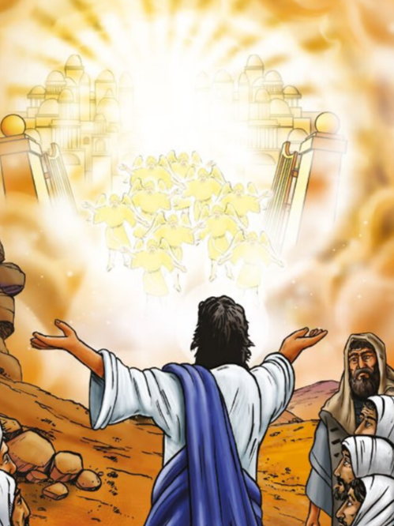How does this piece of scripture make you feel?   
Why do you feel this way?