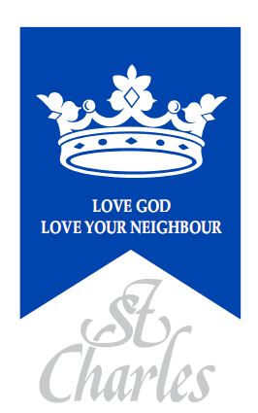
St. Charles Catholic Primary School
83 St Charles Square, London, W10 6EB

Supplementary Information Form

Requested start date: _______________________ Year Group: Reception_

Child’s Details
Child’s Forename:
Child’s Surname:
Date of Birth:
Gender:
Home Address:
Postcode:

Parent(s)/Carer(s) Details
Parent(s)/Carer(s) name:
Telephone number(s):
Email (s):
Relationship to child:  Circle as appropriate | Mother / Father  Other  (please specify)_____________ | Mother / Father  Other  (please specify)_________________

Details of Religion
Religion of child:
(Please indicate)

Parish you live in:
Church where child was baptised:

Date of baptism, (Original copy of baptism certificate to be returned with this form):
Church you currently attend:

Name of priest providing Certificate of Catholic Practice

The school is committed to protecting the information provided by parents / carers and using it only for the purpose for which is was obtained. For information on the school’s Privacy Notice please look on the school website or contact the school for a hard copy.

I confirm that I have read and understood the Admissions Policy and that the information I have provided is correct. I understand that I must notify the school immediately if there is any change to these details and that should any information I have given prove to be inaccurate that the governors may withdraw any offer of a place even if the child has already started school.

Signed……………………………………………………. Date…..…………………….

Checklist: Have you enclosed?
- ORIGINAL COPY of Birth Certificate
- ORIGINAL COPY of Certificate of Baptism (if applicable)
- Completed Certificate of Catholic / Religious Practice (as applicable)
- COPY proof of address (used for this application) eg. current Council Tax,
gas, electricity or water bill or bank statement (less than 3 months old)
- Completed Free School Meal form

Please indicate how you heard about St. Charles Catholic Primary School:

- A friend
- Open day
- Parish Newsletter
- Local Authority

- Other: _ _ _ _ _ _ _ _ _ _ _ _ _ _ _ _ _ _ _
---------------------------------------------------------------------------------------------------------------------------------------

For office use: Documents submitted by parents
- Copy of Birth Certificate Copy of Certificate of Baptism

- Copy of Certificate of Baptism
- Certificate of Catholic Practice
- Certificate of Religious Practice

- FSM form
- Copy proof of address
- Other documents attached: -

Received by___________________ Date: _______________

